*The objective was to simulate a business scenario where I acted as a data analyst for Tata Group's online retail segment. My goal was to analyze a large dataset of customer transactions and generate clear, actionable insights through interactive dashboards. These insights were meant to support strategic decisions for both the CEO and the CMO.*

*This comprehensive program encompassed four key tasks:*

1.I learned to anticipate the questions business leaders might ask, enhancing my ability to analyze data from a leadership perspective.

2nd and 3rd task was choosing the right and effective visual representations for various data scenarios, ensuring clarity and impact in data presentation

4.The final task emphasized effectively on conveying findings and explaining their relevance to each scenario. After loading the dataset into Power BI, I cleaned up invalid records like negative unit prices and quantities to ensure accurate and reliable insights.

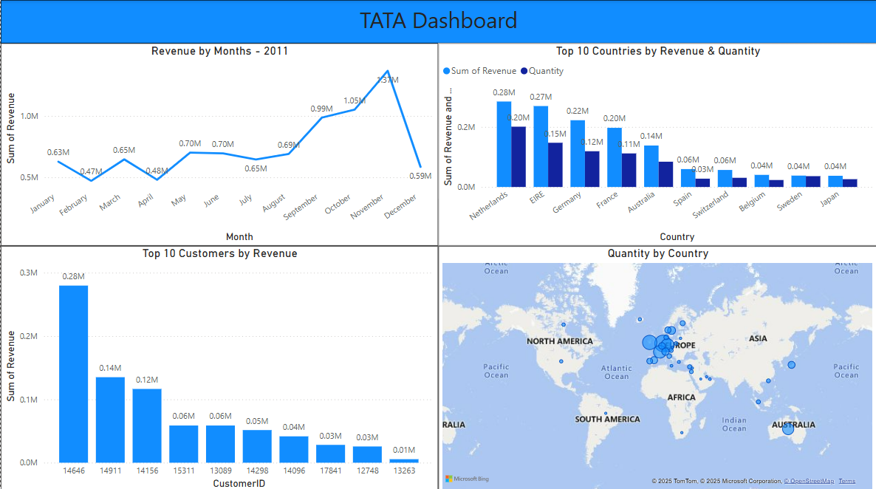

***The dashboard depicts the customer transactions all over the world.****I used Power BI because of its strong integration with Excel, easy-to-use drag-and-drop interface, DAX support for complex measures, and ability to build dynamic dashboards that respond to filters and slicers.*

*For the* ***CEO****, I focused on high-level KPIs like total revenue, profit, and regional performance to support strategic decisions.  
For the* ***CMO****, I emphasized customer segments, product performance — all of which supports campaign planning and targeting.*

*One* ***challenge*** *I faced was maintaining dashboard clarity while visualizing complex data. To solve this, I used appropriate chart types — for example, bar charts for category comparisons and line charts for trend analysis. I also used filters and slicers to enable interactive analysis, reducing clutter while still providing depth.*